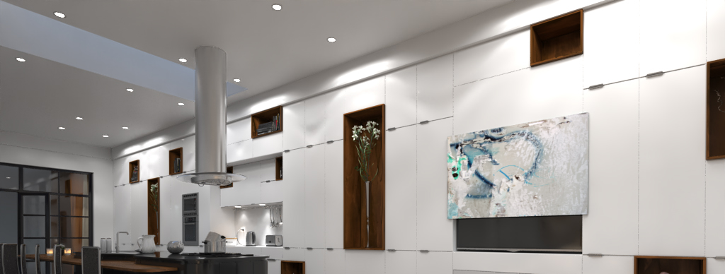
www.ultraliftaustralia.com.au | Ph: +61 3 9459 0873
sales@ultraliftaustralia.com.au | 82 Dougharty Road, Heidelberg West, VIC 3081 Australia

PICASSO Art Lift
Required Design Information

Sliding Direction

☐ Horizontal ☐ Vertical

Moving Panels (supplied by installer)

Thickness (mm):
Material (kg):
Specific panel size requirement | Width: | Height: | Depth:
* Standard approach is to design around nominated TV size for minimum panel sizing

Cavity Restrictions

Width: | Height: | Depth:

TV (mounting responsibility of installer)

Make and Model Number:
* If TV has not been purchased yet, we will supply maximum screen sizing

Colour

☐ Black ☐ White

NOTES:

- Comes standard with IR and Contact Closure.
- Please inform if you need another option for control (extra charges may apply).
- Custom options available to mount Sound bar brackets (extra charge, make and model number required).

