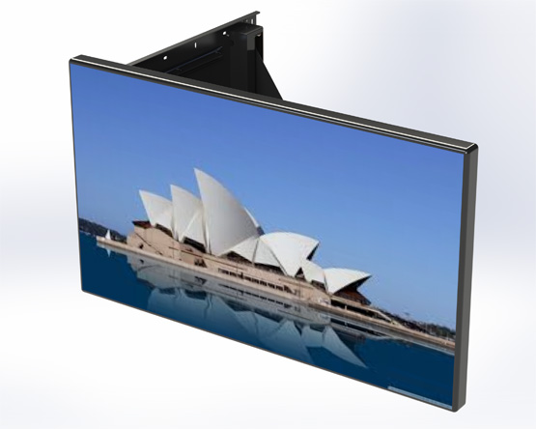
www.ultraliftaustralia.com.au | Ph: +61 3 9459 0873
sales@ultraliftaustralia.com.au | 82 Dougharty Road, Heidelberg West, VIC 3081 Australia

FREEDOM MOTORISED
Required Design Information

TV (mounting responsibility of installer)

Make and Model Number:
* If TV has not been purchased yet, we will supply maximum screen sizing

Colour

☐ Black ☐ White

ROTATION (BIRD’s EYE / PLAN VIEW)

☐ Clockwise ☐ Anticlockwise

NOTES:

- See Standard Freedom Motorised Spec Sheet for dimensions & mounting information
- Comes standard with IR and Contact Closure
- Please inform if you need another option for control (extra charges may apply)
- Custom options available to mount Sound bar brackets (extra charge, make and model number required)

